

Press release no. 5
ECOMONDO 2024: START-UPS KEY PLAYERS IN THE INNOVATION DISTRICT

- The show consolidates its role as an incubator for creativeness with the Innovation District and the Start-Up & Scale-Up area, giving innovative companies a specific space
- 19 startups will present cutting-edge solutions in various areas of sustainability: from waste management to the circular bioeconomy, textiles, agriculture and water management
- The Lorenzo Cagnoni Award for Green Innovation will celebrate the most innovative projects among the exhibitors in six thematic categories, evaluating originality, economic and environmental impact and adherence to the principles of circularity

Rimini, 29th October 2024 - Ecomondo (Rimini Expo Centre, November 5th – 8th, 2024) confirms its position as a reference point for innovation in the Green and Circular Economy sector by consolidating its role as an incubator and creating new business opportunities. The Start-Up & Scale-Up area, an integral part of the Innovation District, is a physical and virtual space for young Italian and international companies that offer technologies, services and solutions for the ecological transition and new models of circular and regenerative economy.
The initiative aims to create a venue for exchange and sharing between tradition and innovation by fostering dialogue between the business world and new entrepreneurial companies. The goal is to encourage seeing the Italian innovative system as a primary interlocutor in the development of green products, services and technologies for the circular economy at an international level.
Proof of growing attention to innovation in this sector can be seen in the number of applications received to participate in the Start-Up & Scale-Up area: as many as 144, a 21% increase compared to 2023, when applications had already increased by 50%. Among them, 7 come from abroad, demonstrating the international interest in the initiative. 19 startups have been selected for the 2024 edition, 3 of which, the most innovative, will receive the Lorenzo Cagnoni Award for Green Innovation.

WASTE AS RESOURCE
Several innovative solutions stand out among the selected start-ups in the waste management and re-utilisation sector. Waste to Energy focuses on treating organic matter with its “zero emission” pilot system, which totally eliminates the production of fumes, odours and pollutants. This technology is a significant step forward in municipal waste management. Ricehouse Srl SB is redefining the concept of sustainable bio-architecture by re-utilising waste from the rice industry to create innovative building products. Meanwhile, WeSEPO is transforming the approach to waste management in Zambia by creating an efficient network between producers, collectors and recyclers. Iotilize brings digital innovation to this sector by offering advanced software for monitoring containers, tanks and silos, thus optimising waste management on a large scale. T.E.C. Srl stands out for its patented technique for recovering materials from rubber compounds, including end-of-life tyres, opening up new possibilities in recycling complex materials. These start-ups show how innovative waste management is not only able to reduce environmental impact, but can also create new economic opportunities in various sectors.
CIRCULAR AND REGENERATIVE BIO-ECONOMY
The circular bio-economy is evolving rapidly with several start-ups bringing innovative solutions. Canapack is redefining the packaging industry with its bio-based and biodegradable products. Repet Srl has developed a pilot system that turns plastic waste into valuable products, while SMUSH Materials is creating compostable packaging solutions from agricultural by-products through fungal fermentation processes. Nlcomp® is opening new frontiers in composite materials with its rComposite® technology, offering recyclable alternatives to traditional composites. Both Alkivio and AgroMateriae are transforming agro-industrial by-products into new sustainable raw materials, demonstrating the potential of the circular bio-economy in various industries.

TEXTILE DISTRICT
The textile industry is undergoing a sustainable transformation thanks to innovators such as EBE Collective Srl, which offers creative upcycling solutions, and Cloov, which is making the adoption of circular business models in fashion retail easier. These start-ups are redefining the life cycle of textile products by promoting practices such as rental, resale and repair.

BIOENERGY & AGRICULTURE
In the field of bioenergy and sustainable agriculture, BiodieselKit is targeting the transportation sector with its technology that enables using 100% biodiesel in existing diesel engines. Natural Development Group, on the other hand, is innovating the eco-sustainable agriculture sector by developing natural and organic fertilizers and products that promise to significantly reduce the environmental impact of farming.

WATER CYCLE & BLUE ECONOMY
Water resource management is seeing innovative solutions emerge, such as that by MOIWUS Srl, whose RiPura technology offers an innovative approach to wastewater treatment. Innovation Foundry Srl completes the picture with its patented technology for water decontamination and asbestos denaturation, thus addressing critical environmental challenges.

SITE & SOIL RESTORATION – BIOTECHNOLOGY
In the field of environmental restoration, Clinica del Suolo is tackling the crucial challenge of soil decontamination. The company’s innovative approach, based on bioremediation techniques, offers a sustainable solution for recovering polluted soils, thus contributing to preserving this non-renewable resource. Lastly, in the biotechnology sector, Ste-Sanitizing Technologies is innovating in the field of indoor sanitisation with eco-friendly devices for air and surface purification, demonstrating how technology can improve quality of life while maintaining a sustainable approach.

LORENZO CAGNONI AWARD FOR GREEN INNOVATION
The Lorenzo Cagnoni Award for Green Innovation, now at its second edition, is a celebration of the President of Rimini Fiera’s legacy, and also of IEG, which conceived and organized the first edition of Ecomondo in 1997 (then Ricicla). This award is given to the most innovative projects among exhibitors that stand out for their contribution to the ecological transition.
A committee of experts will assess the projects according to strict criteria: originality, business model, economic and environmental impact, consequences for local supply chains and production systems, and adherence to circularity principles. This multi-dimensional assessment ensures that the awarded projects are not only innovative, but also have a tangible and positive impact on the economy and the environment.
The award is divided into six categories, corresponding to Ecomondo’s thematic macro-areas, with the most innovative project in each area being selected. Innovations range from waste management with advanced technologies for recycling and separate waste collection, to water resource management with solutions for predictive monitoring and biological wastewater treatment. The bioenergy and agriculture sector will see projects for energy storage and energy efficiency emerge, while the circular bioeconomy will present innovations in biomaterials and agri-food waste re-utilisation.
The award ceremony, scheduled for 6th November, will offer an important showcase for the winners and their projects by celebrating the importance of sustainable innovation.

ABOUT ECOMONDO 2024
Event: International trade show; Organiser: Italian Exhibition Group S.p.A.; Frequency: annual; Edition: 27th; Dates: 5-8 November; mail: ecomondo@iegexpo.it; Website: www.ecomondo.com;
Facebook: www.facebook.com/EcomondoRimini; Twitter: http://twitter.com/Ecomondo;
LinkedIn: https://www.linkedin.com/company/ecomondo-the-green-technologies-expo/

PRESS CONTACT - ITALIAN EXHIBITION GROUP
head of media & corporate communication: Elisabetta Vitali; press office manager: Marco Forcellini, Pier Francesco Bellini; international press office coordinator: Silvia Giorgi; press office coordinator: Luca Paganin; press office specialists: Nicoletta Evangelisti, Mirko Malgieri; media@iegexpo.it
MEDIA AGENCY Hill & Knowlton
Francesca De Angelis, +39 342 7460159 - francesca.deangelis@hillandknowlton.com
Valentina Corsi - +39 3270425730 - valentina.corsi@hillandknowlton.com
Alessio Ricciuto - alessio.ricciuto@hillandknowlton.com
Foreign Press - Oksana Smirnova - smirnova.consultant@hillandknowlton.com

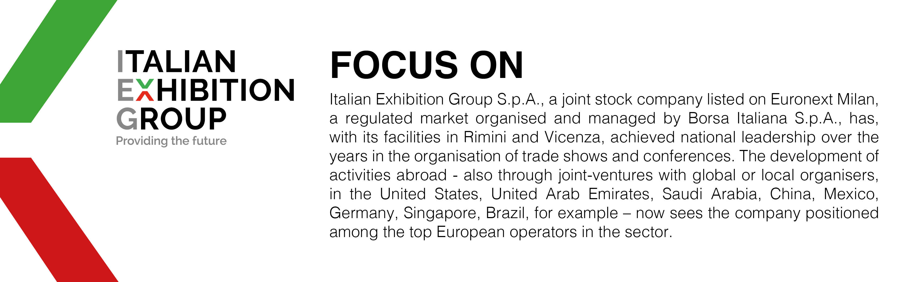

This press release contains forecast elements and estimates that reflect the management’s current opinions (“forward-looking statements”), particularly regarding future management performance, realization of investments, cash flow trends and the evolution of the financial structure. For their very nature, forward-looking statements have a component of risk and uncertainty, as they depend on the occurrence of future events. The effective results may differ (even significantly) from those announced, due to numerous factors, including, only by way of example: food service market and tourist flow trends in Italy, gold and jewellery market trends, green economy market trends; the evolution of raw material prices; general macroeconomic conditions; geopolitical factors and evolutions in the legislative framework. Moreover, the information contained in this release does not claim to be complete, and has not been verified by independent third parties. Forecasts, estimates and objectives contained herein are based on the information available to the Company as at the date of this release.

